Kerberos

Kerberos provides a centralized authentication server whose function is to authenticate users to servers and servers to users. In Kerberos Authentication server and database is used for client authentication. Kerberos runs as a third-party trusted server known as the Key Distribution Center (KDC). Each user and service on the network is a principal.
The main components of Kerberos are:
- Authentication Server (AS):
The Authentication Server performs the initial authentication and ticket for Ticket Granting Service.
- Database:
The Authentication Server verifies the access rights of users in the database.
- Ticket Granting Server (TGS):
The Ticket Granting Server issues the ticket for the Server
Kerberos Overview:

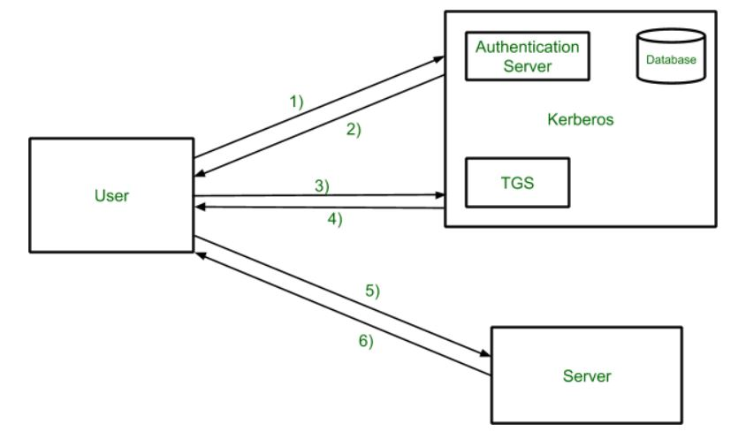

- Step-1:
User login and request services on the host. Thus user requests for ticket-granting service.
- Step-2:
Authentication Server verifies user’s access right using database and then gives ticket-granting-ticket and session key. Results are encrypted using the Password of the user.
- Step-3:
The decryption of the message is done using the password then send the ticket to Ticket Granting Server. The Ticket contains authenticators like user names and network addresses.
- Step-4:
Ticket Granting Server decrypts the ticket sent by User and authenticator verifies the request then creates the ticket for requesting services from the Server.
- Step-5:
The user sends the Ticket and Authenticator to the Server.
- Step-6:
The server verifies the Ticket and authenticators then generate access to the service. After this User can access the services.

Kerberos Limitations
- Each network service must be modified individually for use with Kerberos
- It doesn’t work well in a timeshare environment
- Secured Kerberos Server
- Requires an always-on Kerberos server
- Stores all passwords are encrypted with a single key
- Assumes workstations are secure
- May result in cascading loss of trust.
- Scalability

Is Kerberos Infallible?
No security measure is 100% impregnable, and Kerberos is no exception. Because it’s been around for so long, hackers have had the ability over the years to find ways around it, typically through forging tickets, repeated attempts at password guessing (brute force/credential stuffing), and the use of malware, to downgrade the encryption.
Despite this, Kerberos remains the best access security protocol available today. The protocol is flexible enough to employ stronger encryption algorithms to combat new threats, and if users employ good password-choice guidelines, you shouldn’t have a problem!

What is Kerberos Used For?
Although Kerberos can be found everywhere in the digital world, it is commonly used in secure systems that rely on robust authentication and auditing capabilities. Kerberos is used for Posix, Active Directory, NFS, and Samba authentication. It is also an alternative authentication system to SSH, POP, and SMTP.

Applications
- User Authentication: User Authentication is one of the main applications of Kerberos. Users only have to input their username and password once with Kerberos to gain access to the network. The Kerberos server subsequently receives the encrypted authentication data and issues a ticket granting ticket (TGT).
- Single Sign-On (SSO): Kerberos offers a Single Sign-On (SSO) solution that enables users to log in once to access a variety of network resources. A user can access any network resource they have been authorized to use after being authenticated by the Kerberos server without having to provide their credentials again.
- Mutual Authentication: Before any data is transferred, Kerberos uses a mutual authentication technique to make sure that both the client and server are authenticated. Using a shared secret key that is securely kept on both the client and server, this is accomplished. A client asks the Kerberos server for a service ticket whenever it tries to access a network resource. The client must use its shared secret key to decrypt the challenge that the Kerberos server sends via encryption. If the decryption is successful, the client responds to the server with evidence of its identity.
- Authorization: Kerberos also offers a system for authorization in addition to authentication. After being authenticated, a user can submit service tickets for certain network resources. Users can access just the resources they have been given permission to use thanks to information about their privileges and permissions contained in the service tickets.
- Network Security: Kerberos offers a central authentication server that can regulate user credentials and access restrictions, which helps to ensure network security. In order to prevent unwanted access to sensitive data and resources, this server may authenticate users before granting them access to network resources.

IP security (IPSec)

S
Sakshi98

• Read
• Discuss
• Courses

Pre-Requisite: Types of Internet Protocol
IP Sec (Internet Protocol Security) is an Internet Engineering Task Force (IETF) standard suite of protocols between two communication points across the IP network that provide data authentication, integrity, and confidentiality. It also defines the encrypted, decrypted, and authenticated packets. The protocols needed for secure key exchange and key management are defined in it.

Uses of IP Security
IPsec can be used to do the following things:
- To encrypt application layer data.
- To provide security for routers sending routing data across the public internet.
- To provide authentication without encryption, like to authenticate that the data originates from a known sender.
- To protect network data by setting up circuits using IPsec tunneling in which all data being sent between the two endpoints is encrypted, as with a Virtual Private Network(VPN) connection.

Components of IP Security
It has the following components:
- Encapsulating Security Payload (ESP)
- Authentication Header (AH)
- Internet Key Exchange (IKE)
1. Encapsulating Security Payload (ESP): It provides data integrity, encryption, authentication, and anti-replay. It also provides authentication for payload.
2. Authentication Header (AH): It also provides data integrity, authentication, and anti-replay and it does not provide encryption. The anti-replay protection protects against the unauthorized transmission of packets. It does not protect data confidentiality.
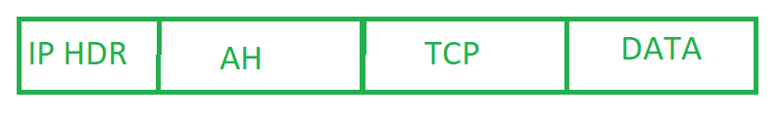
IP Header
3. Internet Key Exchange (IKE): It is a network security protocol designed to dynamically exchange encryption keys and find a way over Security Association (SA) between 2 devices. The Security Association (SA) establishes shared security attributes between 2 network entities to support secure communication. The Key Management Protocol (ISAKMP) and Internet Security Association provides a framework for authentication and key exchange. ISAKMP tells how the setup of the Security Associations (SAs) and how direct connections between two hosts are using IPsec. Internet Key Exchange (IKE) provides message content protection and also an open frame for implementing standard algorithms such as SHA and MD5. The algorithm’s IP sec users produce a unique identifier for each packet. This identifier then allows a device to determine whether a packet has been correct or not. Packets that are not authorized are discarded and not given to the receiver.
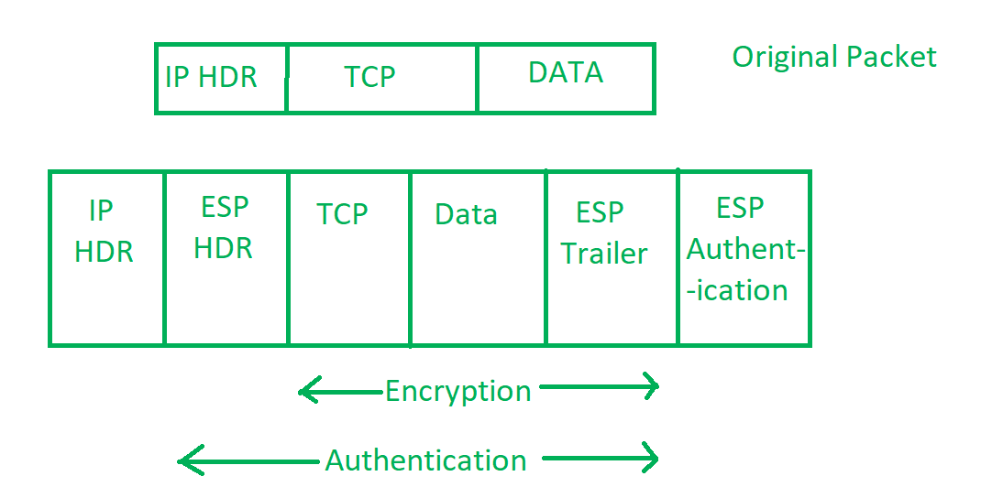
Packets in Internet Protocol

IP Security Architecture
IPSec (IP Security) architecture uses two protocols to secure the traffic or data flow. These protocols are ESP (Encapsulation Security Payload) and AH (Authentication Header). IPSec Architecture includes protocols, algorithms, DOI, and Key Management. All these components are very important in order to provide the three main services:
- Confidentiality
- Authenticity
- Integrity
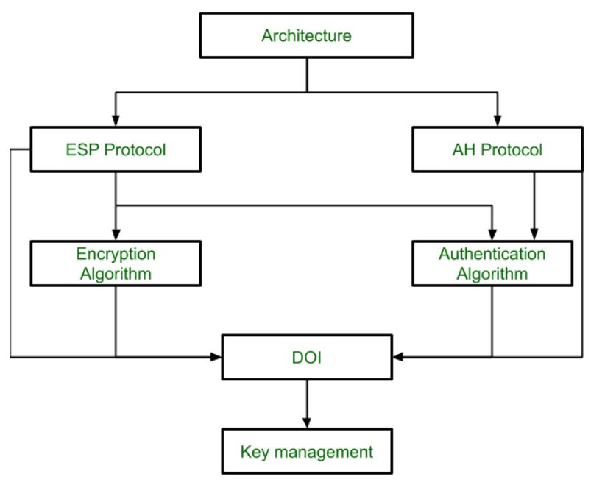
IP Security Architecture

Working on IP Security
- The host checks if the packet should be transmitted using IPsec or not. This packet traffic triggers the security policy for itself. This is done when the system sending the packet applies appropriate encryption. The incoming packets are also checked by the host that they are encrypted properly or not.
- Then IKE Phase 1 starts in which the 2 hosts( using IPsec ) authenticate themselves to each other to start a secure channel. It has 2 modes. The Main mode provides greater security and the Aggressive mode which enables the host to establish an IPsec circuit more quickly.
- The channel created in the last step is then used to securely negotiate the way the IP circuit will encrypt data across the IP circuit.
- Now, the IKE Phase 2 is conducted over the secure channel in which the two hosts negotiate the type of cryptographic algorithms to use on the session and agree on secret keying material to be used with those algorithms.
- Then the data is exchanged across the newly created IPsec encrypted tunnel. These packets are encrypted and decrypted by the hosts using IPsec SAs.
- When the communication between the hosts is completed or the session times out then the IPsec tunnel is terminated by discarding the keys by both hosts.

Features of IPSec
- Authentication: IPSec provides authentication of IP packets using digital signatures or shared secrets. This helps ensure that the packets are not tampered with or forged.
- Confidentiality: IPSec provides confidentiality by encrypting IP packets, preventing eavesdropping on the network traffic.
- Integrity: IPSec provides integrity by ensuring that IP packets have not been modified or corrupted during transmission.
- Key management: IPSec provides key management services, including key exchange and key revocation, to ensure that cryptographic keys are securely managed.
- Tunneling: IPSec supports tunneling, allowing IP packets to be encapsulated within another protocol, such as GRE (Generic Routing Encapsulation) or L2TP (Layer 2 Tunneling Protocol).
- Flexibility: IPSec can be configured to provide security for a wide range of network topologies, including point-to-point, site-to-site, and remote access connections.
- Interoperability: IPSec is an open standard protocol, which means that it is supported by a wide range of vendors and can be used in heterogeneous environments.

Advantages of IPSec
- Strong security: IPSec provides strong cryptographic security services that help protect sensitive data and ensure network privacy and integrity.
- Wide compatibility: IPSec is an open standard protocol that is widely supported by vendors and can be used in heterogeneous environments.
- Flexibility: IPSec can be configured to provide security for a wide range of network topologies, including point-to-point, site-to-site, and remote access connections.
- Scalability: IPSec can be used to secure large-scale networks and can be scaled up or down as needed.
- Improved network performance: IPSec can help improve network performance by reducing network congestion and improving network efficiency.

Disadvantages of IPSec
- Configuration complexity: IPSec can be complex to configure and requires specialized knowledge and skills.
- Compatibility issues: IPSec can have compatibility issues with some network devices and applications, which can lead to interoperability problems.
- Performance impact: IPSec can impact network performance due to the overhead of encryption and decryption of IP packets.
- Key management: IPSec requires effective key management to ensure the security of the cryptographic keys used for encryption and authentication.
- Limited protection: IPSec only provides protection for IP traffic, and other protocols such as ICMP, DNS, and routing protocols may still be vulnerable to attacks.

Language: null

Transport and Tunnel Modes in IPsec
The IPsec standards define two distinct modes of IPsec operation, transport mode and tunnel mode. The key difference between transport and tunnel mode is where policy is applied. In tunnel mode, the original packet is encapsulated in another IP header. The addresses in the other header can be different.
The packets can be protected by AH, ESP, or both in each mode. The modes differ in policy application, as follows:
- In transport mode, the IP addresses in the outer header are used to determine the IPsec policy that will be applied to the packet.
- In tunnel mode, two IP headers are sent. The inner IP packet determines the IPsec policy that protects its contents.
Tunnel mode can be applied to any mix of end systems and intermediate systems, such as security gateways.
In transport mode, the IP header, the next header, and any ports that the next header supports can be used to determine IPsec policy. In effect, IPsec can enforce different transport mode policies between two IP addresses to the granularity of a single port. For example, if the next header is TCP, which supports ports, then IPsec policy can be set for a TCP port of the outer IP address.
Tunnel mode works only for IP-in-IP packets. In tunnel mode, IPsec policy is enforced on the contents of the inner IP packet. Different IPsec policies can be enforced for different inner IP addresses. That is, the inner IP header, its next header, and the ports that the next header supports can enforce a policy. Unlike transport mode, in tunnel mode the outer IP header does not dictate the policy of its inner IP packet.
Therefore, in tunnel mode, IPsec policy can be specified for subnets of a LAN behind a router and for ports on those subnets. IPsec policy can also be specified for particular IP addresses, that is, hosts, on those subnets. The ports of those hosts can also have a specific IPsec policy. However, if a dynamic routing protocol is run over a tunnel, do not use subnet selection or address selection because the view of the network topology on the peer network could change. Changes would invalidate the static IPsec policy. For examples of tunneling procedures that include configuring static routes, see Protecting a VPN With IPsec.
In Oracle Solaris, tunnel mode can be enforced only on an IP tunneling network interface. For information about tunneling interfaces, see Chapter 4, About IP Tunnel Administration, in Administering TCP/IP Networks, IPMP, and IP Tunnels in Oracle Solaris 11.2 . IPsec policy provides a tunnel keyword to select an IP tunneling network interface. When the tunnel keyword is present in a rule, all selectors that are specified in that rule apply to the inner packet.
The following figure shows an IP header with an unprotected TCP packet.
Figure 6-3 Unprotected IP Packet Carrying TCP Information
In transport mode, ESP protects the data as shown in the following figure. The shaded area shows the encrypted part of the packet.
Figure 6-4 Protected IP Packet Carrying TCP Information
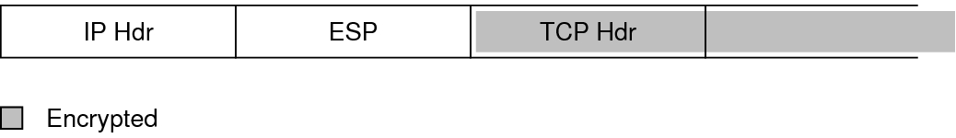
In tunnel mode, the entire packet is inside the ESP header. The packet in Figure 6–3 is protected in tunnel mode by an outer IPsec header and, in this case, ESP, as shown in the following figure.
Figure 6-5 IPsec Packet Protected in Tunnel Mode
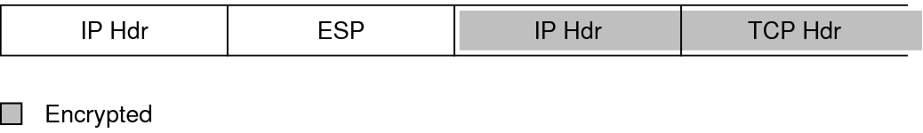
IPsec policy provides keywords for tunnel mode and transport mode. For more information, review the following:
- For details on per-socket policy, see the ipsec(7P) man page.
- For an example of per-socket policy, see How to Use IPsec to Protect Web Server Communication With Other Servers.
- For more information about tunnels, see the ipsecconf(1M) man page.
- For an example of tunnel configuration, see How to Protect the Connection Between Two LANs With IPsec in Tunnel Mode.

What is Email Security?

S
shraddhapand29

• Read
• Discuss
• Courses

Email (short for electronic mail ) is a digital method by using it we exchange messages between people over the internet or other computer networks. With the help of this, we can send and receive text-based messages, often an attachment such as documents, images, or videos, from one person or organization to another.
It was one of the first applications developed for the internet and has since become one of the most widely used forms of digital communication. It has an essential part of personal and professional communication, as well as in marketing, advertising, and customer support.
In this article, we will understand the concept of email security, how we can protect our email, email security policies, and email security best practices, and one of the features of email is an email that we can use to protect the email from unauthorized access.

Email Security:
Basically, Email security refers to the steps where we protect the email messages and the information that they contain from unauthorized access, and damage. It involves ensuring the confidentiality, integrity, and availability of email messages, as well as safeguarding against phishing attacks, spam, viruses, and another form of malware. It can be achieved through a combination of technical and non-technical measures.
Some standard technical measures include the encryption of email messages to protect their contents, the use of digital signatures to verify the authenticity of the sender, and email filtering systems to block unwanted emails and malware, and the non-technical measures may include training employees on how to recognize and respond to phishing attacks and other email security threats, establishing policies and procedures for email use and management, and conducting regular security audits to identify and address vulnerabilities.
We can say that email security is important to protect sensitive information from unauthorized access and ensure the reliability and confidentiality of electronic communication.

Steps to Secure Email:
We can take the following actions to protect our email.
- Choose a secure password that is at least 12 characters long, and contains uppercase and lowercase letters, digits, and special characters.
- Activate the two-factor authentication, which adds an additional layer of security to your email account by requiring a code in addition to your password.
- Use encryption, it encrypts your email messages so that only the intended receiver can decipher them. Email encryption can be done by using the programs like PGP or S/MIME.
- Keep your software up to date. Ensure that the most recent security updates are installed on your operating system and email client.
- Beware of phishing scams: Hackers try to steal your personal information by pretending as someone else in phishing scams. Be careful of emails that request private information or have suspicious links because these are the resources of the phishing attack.
- Choose a trustworthy email service provider: Search for a service provider that protects your data using encryption and other security measures.
- Use a VPN: Using a VPN can help protect our email by encrypting our internet connection and disguising our IP address, making it more difficult for hackers to intercept our emails.
- Upgrade Your Application Regularly: People now frequently access their email accounts through apps, although these tools are not perfect and can be taken advantage of by hackers. A cybercriminal might use a vulnerability, for example, to hack accounts and steal data or send spam mail. Because of this, it’s important to update your programs frequently.

Email Security Policies
The email policies are a set of regulations and standards for protecting the privacy, accuracy, and accessibility of email communication within the organization. An email security policy should include the following essential components:
- Appropriate Use: The policy should outline what comprises acceptable email usage inside the organization, including who is permitted to use email, how to use it, and for what purpose email we have to use.
- Password and Authentication: The policy should require strong passwords and two-factor authentication to ensure that only authorized users can access email accounts.
- Encryption: To avoid unwanted access, the policy should mandate that sensitive material be encrypted before being sent through email.
- Virus Protection: The policy shall outline the period and timing of email messages and attachment collection.
- Retention and Detection: The policy should outline how long email messages and their attachments ought to be kept available, as well as when they should continue to be removed.
- Training: The policy should demand that all staff members take a course on email best practices, which includes how to identify phishing scams and other email-based threats.
- Incident Reporting: The policy should outline the reporting and investigation procedures for occurrences involving email security breaches or other problems.
- Monitoring: The policy should outline the procedures for monitoring email communications to ensure that it is being followed, including any logging or auditing that will be carried out.
- Compliance: The policy should ensure compliance with all essential laws and regulations, including the health
- Insurance rules, including the health portability and accountability act and the General Data Protection Regulation (GDPR)(HIPPA).
- Enforcement: The policy should specify the consequences for violating the email security policy, including disciplinary action and legal consequences if necessary.
Hence, organizations may help safeguard sensitive information and lower the risk of data breaches and other security incidents by creating an email security strategy.
Now, Let’s look at how to enable the confidential mode in our Gmail account. With Gmail.com, there is a feature called confidential mode that we may use to safeguard our email.These are the steps to use this feature:
Step 1: On your computer, go to Gmail and click compose as shown in the below screenshot.
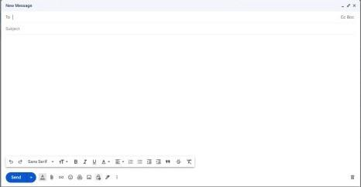

Step 2: If you have already enabled confidential mode for an email, click Edit in the bottom right corner of the window to add an expiration date and a passcode. These setting impact both the message text and any attachments.
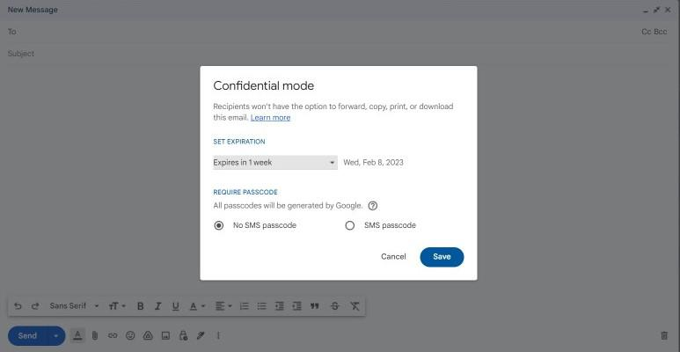

If you select “No SMS passcode,” recipients using the Gmail app will be able to open it directly and those who don’t use Gmail will receive an email with a passcode.
On the other hand, if you select the “SMS passcode” recipients will get a passcode by a text message for that you have to provide the recipient’s phone number.
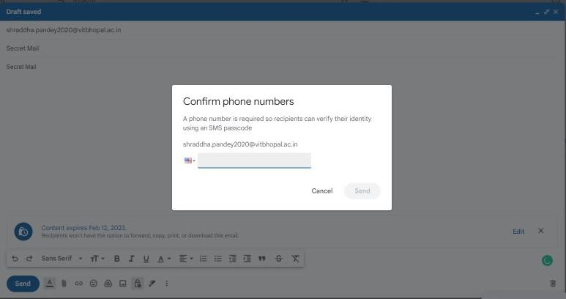

Step 3: After providing the phone number click the save button.
Step 4: In the next step write the email and sent it to the recipient.
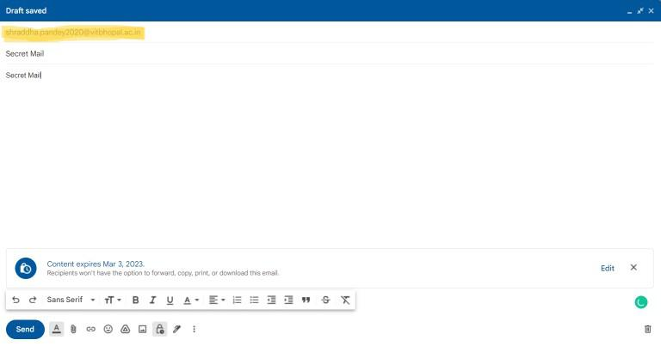

Remove Access before Expiration:
We can prevent the receiver from viewing the email before it does. Prior to the message’s expiration date or until the sender removes access, the recipient may examine the message and any attached files. This mode disables attachments and prevents us from copying, pasting, downloading, printing, or forwarding message text.
Even so, while this mode aids in preventing receivers from unintentionally sharing your email, it does not stop them from capturing screenshots or images of your messages or attachments
It does not stop receivers from capturing screenshots or images of your emails or attachments, though this mode does make it more difficult for them to unintentionally share your emails with others. The message or attachment can still be downloaded by the recipient even if they have malicious software installed on their computer.

Privacy Enhanced Mail (PEM) and it’s Working

L
lalithakesaraju

• Read
• Discuss
• Courses

Privacy Enhanced Mail (PEM) is an email security standard to provide secure electronic mail communication over the internet. Security of email messages has become extremely important nowadays. In order to deal with the security issues of emails the internet architecture board has adopted it.
The PEM mainly provides the following services –
- Confidentiality –
Confidentiality refers to the act of preventing unauthorized access to the information hence protecting it. The confidentiality is obtained in PEM by encrypting the messages by using various standard algorithms such as Data Encryption Standard (DES). DES in cipher block chaining mode is being currently used by PEM.
- Integrity –
Data integrity refers to the consistency of data through out its life cycle. This is obtained by using a unique concept called as message digest where message digest is a hash function which converts the message into an image called digest on taking the message as input. PEM uses RSA encryption, MD2 and MD5 hash functions to generate the digests. An octet value is generated from the hash functions which is then encrypted which is then run against the message digest by the receiver assured of the integrity of the message that is transmitted.
Working of PEM :
The PEM works basically in 4 main steps.
- Canonical Conversion –
This step involves the conversion of the message into a standard format that is independent of the computer architecture and the operating system of the sender and the receiver. If the sender and receiver has different computer architecture or operating system. It may lead to generation of different message digest due to difference in their interpretation because of syntactical difference from one operating system to an other.

- Digital Signature –
In this step, the digital signature is generated by encrypting the message digest of an email message with the sender’s private key.
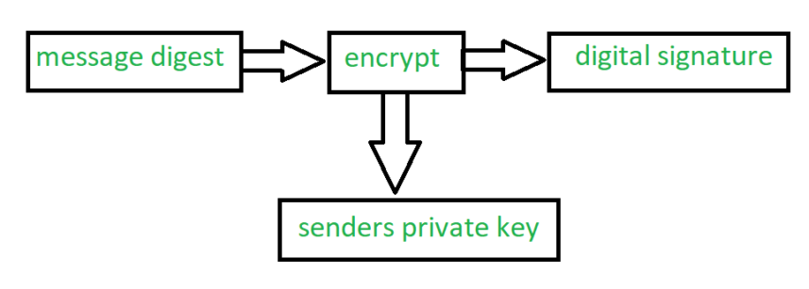

- Encryption –
The encrypted message is generated by encrypting the original message and digital signature together along with the symmetric key as shown in the figure below.This step is very crucial in order to obtain the confidentiality.
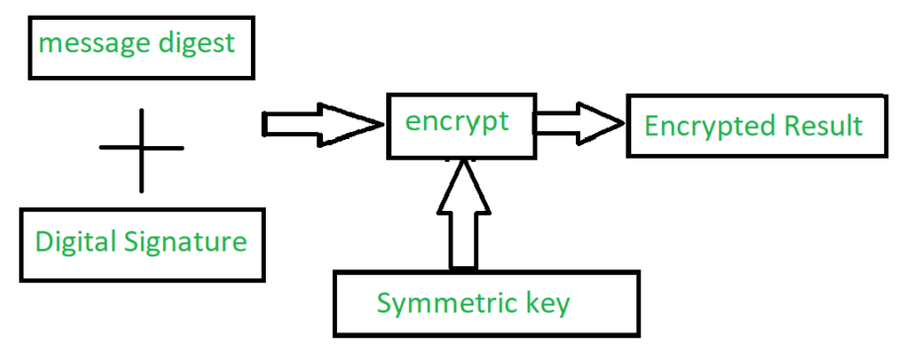

- Base-64 Encoding –
This is the last step where the binary output is transformed into character output. The binary output which is 24 bits is divided into 4 equal sets and mapped with the 8 bit character output generating a decimal code. Now PEM uses a separate map table and each number from the code generated is mapped with its corresponding value from the mapping table and binary equivalent corresponding to the 8 bit ASCII of the character is written.

Difference between PGP and S/MIME

M
MKS075

• Read
• Discuss
• Courses

1. Pretty Good Privacy (PGP) : PGP is an open source software package that is designed for the purpose of email security. Phil Zimmerman developed it. It provides the basic or fundamental needs of cryptography. In this multiple steps such are taken to secure the email, these are,
1. Confidentiality
2. Authentication
3. Compression
4. Resemble
5. Segmentation
6. E-mail compatibility
2. Secure/Multipurpose Internet Mail Extension (S/MIME) : S/MIME is a security-enhanced version of Multipurpose Internet Mail Extension (MIME). In this, public key cryptography is used for digital sign, encrypt or decrypt the email. User acquires a public-private key pair with a trusted authority and then makes appropriate use of those keys with email applications.
Difference between PGP and S/MIME :
S.NO | PGP | S/MIME
1. | It is designed for processing the plain texts | While it is designed to process email as well as many multimedia files.
2. | PGP is less costly as compared to S/MIME. | While S/MIME is comparatively expensive.
3. | PGP is good for personal as well as office use. | While it is good for industrial use.
4. | PGP is less efficient than S/MIME. | While it is more efficient than PGP.
5. | It depends on user key exchange. | Whereas it relies on a hierarchically valid certificate for key exchange.
6. | PGP is comparatively less convenient. | While it is more convenient than PGP due to the secure transformation of all the applications.
7. | PGP contains 4096 public keys. | While it contains only 1024 public keys.
8. | PGP is the standard for strong encryption. | While it is also the standard for strong encryption but has some drawbacks.
9. | PGP is also be used in VPNs. | While it is not used in VPNs, it is only used in email services.
10. | PGP uses Diffie hellman digital signature. | While it uses Elgamal digital signature.
11. | In PGP Trust is established using Web of Trust. | In S/MIME Trust is established using Public Key Infrastructure.
12. | PGP doen’t provides authentication. | S/MIME provides authentication.
13. | PGP is used for Securing text messages only. | S/MIME is used for Securing Messages and attachments.
14. | Their is less use of PGP in industry . | While S/MIME is widely used in industry.
15. | Convenience of PGP is low. | Convenience of S/MIME is High.
16. | Administrative overhead of PGP is high. | Administrative overhead of S/MIME is low.

Public Key Infrastructure

S
shikha19b131014

• Read
• Discuss
• Courses

Public key infrastructure or PKI is the governing body behind issuing digital certificates. It helps to protect confidential data and gives unique identities to users and systems. Thus, it ensures security in communications.
The public key infrastructure uses a pair of keys: the public key and the private key to achieve security. The public keys are prone to attacks and thus an intact infrastructure is needed to maintain them.

Managing Keys in the Cryptosystem:
The security of a cryptosystem relies on its keys. Thus, it is important that we have a solid key management system in place. The 3 main areas of key management are as follows:
- A cryptographic key is a piece of data that must be managed by secure administration.
- It involves managing the key life cycle which is as follows:
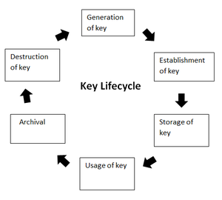
- Public key management further requires:
  - Keeping the private key secret: Only the owner of a private key is authorized to use a private key. It should thus remain out of reach of any other person.
  - Assuring the public key: Public keys are in the open domain and can be publicly accessed. When this extent of public accessibility, it becomes hard to know if a key is correct and what it will be used for. The purpose of a public key must be explicitly defined.
PKI or public key infrastructure aims at achieving the assurance of public key.

Public Key Infrastructure:
Public key infrastructure affirms the usage of a public key. PKI identifies a public key along with its purpose. It usually consists of the following components:
- A digital certificate also called a public key certificate
- Private Key tokens
- Registration authority
- Certification authority
- CMS or Certification management system

Working on a PKI:
Let us understand the working of PKI in steps.
- PKI and Encryption: The root of PKI involves the use of cryptography and encryption techniques. Both symmetric and asymmetric encryption uses a public key. The challenge here is – “how do you know that the public key belongs to the right person or to the person you think it belongs to?”. There is always a risk of MITM(Man in the middle). This issue is resolved by a PKI using digital certificates. It gives identities to keys in order to make the verification of owners easy and accurate.
- Public Key Certificate or Digital Certificate: Digital certificates are issued to people and electronic systems to uniquely identify them in the digital world. Here are a few noteworthy things about a digital certificate. Digital certificates are also called X.509 certificates. This is because they are based on the ITU standard X.509.
  - The Certification Authority (CA) stores the public key of a user along with other information about the client in the digital certificate. The information is signed and a digital signature is also included in the certificate.
  - The affirmation for the public key then thus be retrieved by validating the signature using the public key of the Certification Authority.
- Certifying Authorities: A CA issues and verifies certificates. This authority makes sure that the information in a certificate is real and correct and it also digitally signs the certificate. A CA or Certifying Authority performs these basic roles:
  - Generates the key pairs – This key pair generated by the CA can be either independent or in collaboration with the client.
  - Issuing of the digital certificates – When the client successfully provides the right details about his identity, the CA issues a certificate to the client. Then CA further signs this certificate digitally so that no changes can be made to the information.
  - Publishing of certificates – The CA publishes the certificates so that the users can find them. They can do this by either publishing them in an electronic telephone directory or by sending them out to other people.
  - Verification of certificate – CA gives a public key that helps in verifying if the access attempt is authorized or not.
  - Revocation – In case of suspicious behavior of a client or loss of trust in them, the CA has the power to revoke the digital certificate.

Classes of a Digital Certificate:
A digital certificate can be divided into four broad categories. These are :
- Class 1: These can be obtained by only providing the email address.
- Class 2: These need more personal information.
- Class 3: This first checks the identity of the person making a request.
- Class 4: They are used by organizations and governments.

Process of creation of certificate:
The creation of a certificate takes place as follows:
- Private and public keys are created.
- CA requests identifying attributes of the owner of a private key.
- Public key and attributes are encoded into a CSR or Certificate Signing Request.
- Key owner signs that CSR to prove the possession of a private key.
- CA signs the certificate after validation.

Creation of Trust layers among CA Hierarchies:
Each CA has its own certificate. Thus, trust is built hierarchically where one CA issues certificates to other CAs. Moreover, there is a root certificate that is self-signed. For a root CA, the issuer and the subject are not two separate parties but a single party.

Security of Root CA:
As you saw above, the ultimate authority is the root CA. Hence, the security of root CA is of huge importance. If the private key of a root CA is not taken care of, then it might turn into a catastrophe. This is because anyone disguised as the root CA can then issue certificates. To meet security standards, a root CA should be offline 99.9% of the time. However, it does need to come online to create public and private keys and to issue new certificates. Ideally, these activities should be performed 2-4 times a year.

Use of PKI in Today’s Digital Age:
Today, there are an enormous number of applications that need require authentication. Certifications are needed at millions of places. This can not be done without a Public key infrastructure. The importance of PKI, depending on the use case and needs, has evolved over time. Here is a part of that track.
- For the very first time during the period of 1995 to 2002, the use of PKI was limited to the most important and high-value certificates. This included the certificates of eCommerce websites that enabled them to display the lock icon in the search bar. The goal was to make consumers confident about the security and authenticity of various websites.
- The second episode of PKI emerged around 2003 to 2010 when enterprises came into the picture. It was at this time that employees received laptops and the use of mobile phones was rising. Thus, employees needed access to the organization’s assets even outside the office. That is when the use of PKI looked like the best way for authentication.
- The third phase started in 2011 and is continuing to date. With the advent of new technologies like IoT(Internet of Things) and need the to scale PKI, the use, as well as the challenges in using PKI, have increased tremendously. Today, millions of certificates are issued to authenticate mobile workforces. However, managing this huge number of certificates is quite challenging.
- S/MIME, Document Signing, code or app signing also uses PKI.

Challenges that a PKI Solves:
PKI owes its popularity to the various problems its solves. Some use cases of PKI are:
- Securing web browsers and communicating networks by SSL/TLS certifications.
- Maintaining Access Rights over Intranets and VPNs.
- Data Encryption
- Digitally Signed Software
- Wi-fi Access Without Passwords
Other than these, one of the most important use cases of PKI is based around IoT(Internet of Things). Here are two industries that are using PKI for IoT devices:
- Auto Manufacturers: Cars these days have features like GPS, call for services, assistants, etc. These require communication paths where a lot of data is passed. Making these connections secure is very important to avoid malicious parties hacking into the cars. This is where PKI comes in.
- Medical device Manufacturers: Devices like surgical robots require high security. Also, FDA mandates that any next-generation medical device must be updatable so that bugs can be removed and security issues can be dealt with. PKI is used to issues certificates to such devices.

Disadvantages of PKI:
- Speed: Since PKI uses super complex algorithms to create a secure key pair. So it eventually slows down the process and data transfer.
- Private Key Compromise: Even though PKI can’t be hacked very easily but a private key can be hacked by a professional hacker, since PKI uses Public and Private key to encrypt and decrypt data so with user’s private key in hand and public key which is easily available the information can be decrypted easily.

